XPT NO:02 | EDA – DATA CLEANING

AIM:
To inspect the Global YouTube Statistics dataset, identify its features and missing values, analyze its basic structure, and export the data into CSV, Excel, and SQLite database formats..

PROCEDURE:
- Import the required libraries Pandas, OS, and SQLite3.
- Specify the dataset path and identify the CSV file.
- Load the Global YouTube Statistics.csv file using pd.read_csv().
- Display the first five and last five records.
- Inspect the dataset using .info(), .shape, .columns, and .dtypes.
- Generate descriptive statistical information using .describe().
- Identify missing values using .isnull().sum().
- Check for duplicate records using .duplicated().sum().
- Analyze country-wise and channel-type distributions.
- Generate the correlation matrix for numerical attributes.
- Export the DataFrame into CSV and Excel formats.
- Connect to an SQLite database using sqlite3.
- Store the DataFrame in an SQL table using .to_sql().
- Close the database connection.
- Display a confirmation message after successful file creation.

CODE:
import import os import pandas as pd import sqlite3
# Dataset path path = "/content"
print("Dataset path:", path) print("\nFiles in dataset:") print(os.listdir(path))
# Find CSV file automatically csv_files = [f for f in os.listdir(path)
if f.lower().endswith(".csv")] if not csv_files:
raise FileNotFoundError("No CSV file found.") csv_file = csv_files[0]
print("\nCSV file:", csv_file) # Load dataset
df = pd.read_csv( os.path.join(path, csv_file), encoding="latin1", low_memory=False
)
print("\nFirst 5 rows:") display(df.head())

print("\nLast 5 rows:") display(df.tail()) print("\nDataset information:") df.info()
print("\nShape:") print(df.shape) print("\nColumns:") print(df.columns.tolist()) print("\nData types:") print(df.dtypes) print("\nStatistical description:")
display(df.describe(include="all").T) print("\nMissing values:")
display(df.isnull().sum().sort_values(ascending=False)) print("\nDuplicate rows:")
print(df.duplicated().sum()) print("\nTop 10 Countries:")
display(df["Country"].value_counts().head(10)) print("\nChannel Types:") display(df["channel_type"].value_counts()) print("\nCategories:") display(df["category"].value_counts().head(10)) print("\nCorrelation:") display(df.corr(numeric_only=True))

# Export CSV df.to_csv("youtube_statistics.csv", index=False) # Export Excel
df.to_excel("youtube_statistics.xlsx", index=False) # SQLite database
conn = sqlite3.connect("youtube_statistics.db") df.to_sql(
"youtube_channels", conn, if_exists="replace", index=False
)
conn.close()
print("\nCSV, Excel and SQLite database files created successfully.")

OUTPUT:

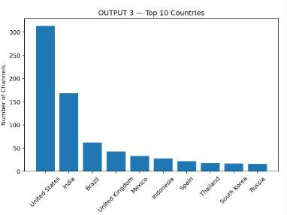

Result:

